**RESUME**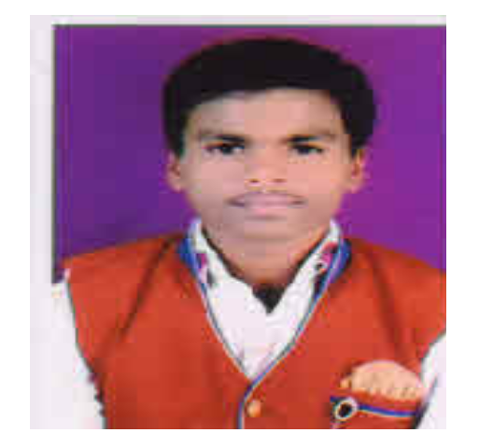

**RAJ SADASHIV KHOBRAGADE**

At- Ambetalaw, Post-Kalimati

Taluka-Goregaon, Dist-Gondia 441801

**Email:** rajskho30@gmail.com

**contact: +91-9623258184**



## CAREER OBJECTIVE

* To take up a challenge and stimulating job in a leading organization and work honestly to prove me as an asset for the organization on my feet and make my own identity in life.

## ACADEMIC CREDENCIALS

|  |  |  |  |
| --- | --- | --- | --- |
| **Qualifications** | **Institution / University** | Year | Marks / Percentage |
| High School (10th) | Maharashtra State Board | Mar.2014 | 71.20% |
| Higher Secondary School (12th) Sci | Maharashtra State Board | Feb.-2016 | 67.23% |
| B.E. MECHANICAL  (6TH SEM) | RTMNU NAGPUR | 2018-19 | Appeared |

**ACADEMIC/ PROFESSIONAL ACHIEVEMENT**

* Under graduate project : Use of quarry sand alternative to conventional sand as a fine aggregate in concrete.

## COMPUTER SKILLS

* Well versed with MS Window, MS Office (MS Word, MS Excel & PowerPoint) MS Outlook & Internet Applications.
* Have done MS-CIT course in computer application from MSBTE, MUMBAI.
* Basic Computer Typing Test by MKCL, Pune

## COMPETENCIES

* Person with positive attitude who believes strongly in hard work dedication and commitment towards work.
* Open to differences in opinion and adaptable to different situations.
* Like interacting with people
* Eager learner.
* Work well under pressure, maintain a professional manner diplomatically and tactfully.
* Good Listener.
* Highly motivated person with a strong belief in team work and creativity. Desire to excel with sincere and consistent efforts.

## LANGUAGES KNOWN

* English : Read, Write and Speak
* Hindi : Read, Write and Speak
* Marathi : Read, Write and Speak

## HOBBIES

* Reading Books and newspapers.
* Drawing
* Playing Cricket
* Singing

## PERSONAL DETAILS

Date of Birth : 30th May 1997

Father Name : Sadashiv Khobragade

Sex : Male

Nationality : Indian

Marital Status : Single

Caste : SC (Mahar)

I hereby certify that the above information given by me is correct to best of my knowledge.

Date:

Place:

**Raj S. Khobragade**